SQS and MQ

What is SQS?
Amazon SQS (Simple Queue Service) is a fully managed message queuing service that enables applications to communicate asynchronously.
Why SQS?
- Decouples applications
- Improves scalability
- Prevents message loss
- Handles traffic spikes
Architecture
Producer (EC2/Lambda/Application)
│
▼
Amazon SQS Queue
│
▼
Consumer (Lambda/EC2/Application)
Components
- Producer – Sends messages.
- Queue – Stores messages.
- Message – Data sent by the producer.
- Consumer – Receives and processes messages.
Queue Types
- Standard Queue
  - High throughput
  - At least once delivery
  - Best effort ordering
- FIFO Queue
  - First-In-First-Out
  - Exactly-once processing
  - Ordered messages
Common Use Cases
- Order processing
- Email notifications
- Image processing
- Background jobs
- Microservices communication

Hands-on 1: Create a Standard Queue
- AWS Console → SQS
- Click Create queue
- Select Standard
- Queue name: my-first-queue
- Click Create queue
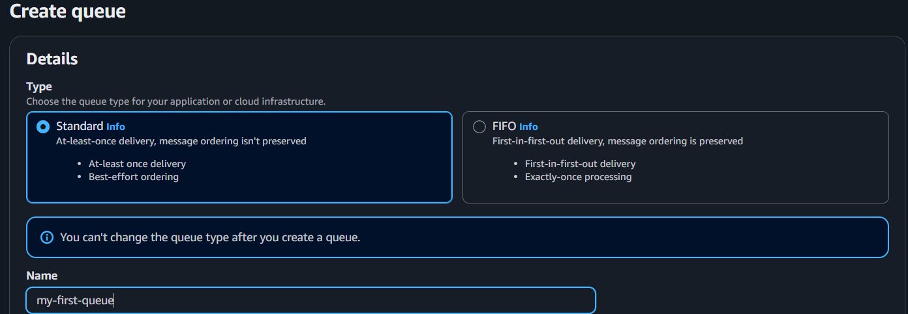

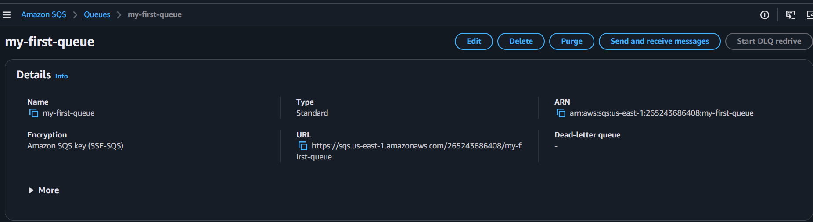

Hands-on 2: Send a Message
- Open my-first-queue
- Click Send and receive messages
- Message body:
Hello AWS SQS
- Click Send message
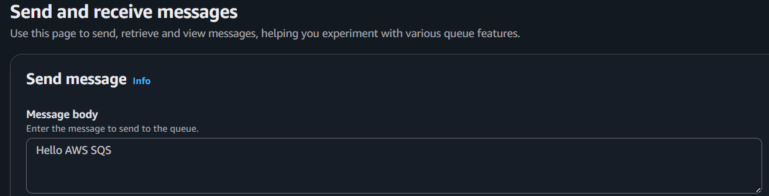

Hands-on 3: Receive a Message
- Click Poll for messages
- Select the message
- Verify:
Hello AWS SQS
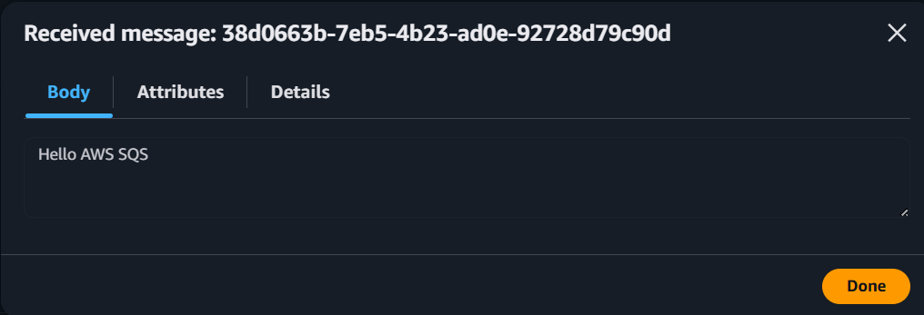

Hands-on 4: Delete a Message
- Select the message
- Click Delete
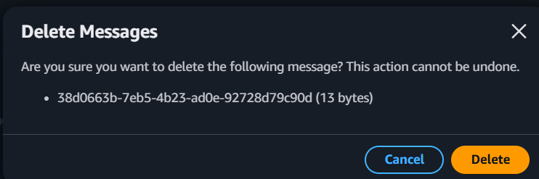

Hands-on 5: Create a FIFO Queue
- Click Create queue
- Select FIFO
- Queue name: orders.fifo
- Click Create queue
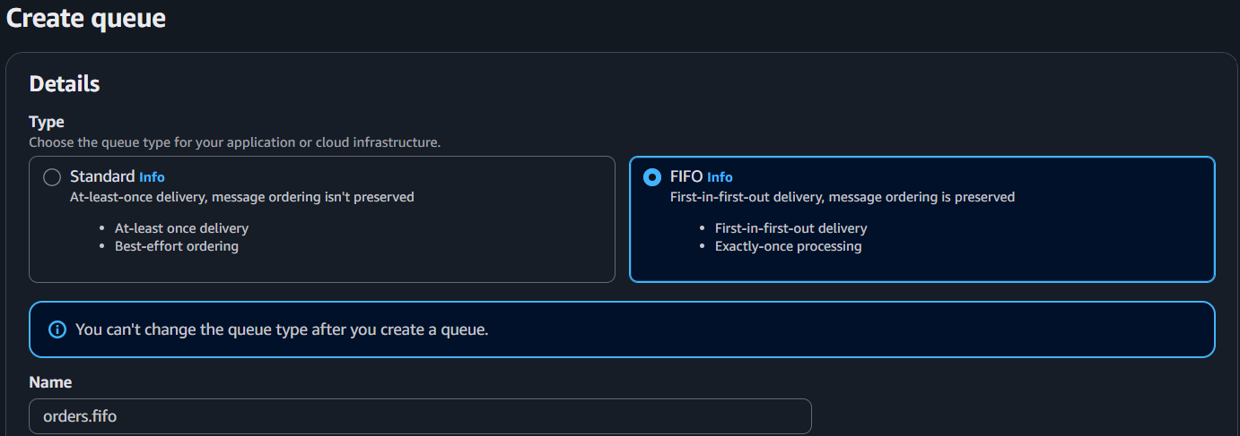

- Send a message with:
  - Message Group ID: group1
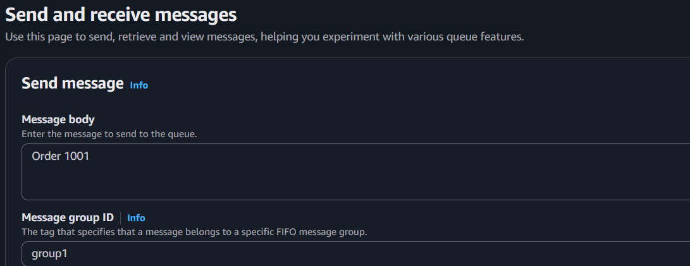
  - Message Body: Order 1001

Hands-on 6: SQS with Lambda
- Create an SQS queue.
- Create a Lambda function.
- Lambda → Add Trigger → SQS.
- Select your queue.
- Click Add.
- Send a message to the queue.
- Verify the Lambda execution in CloudWatch Logs.
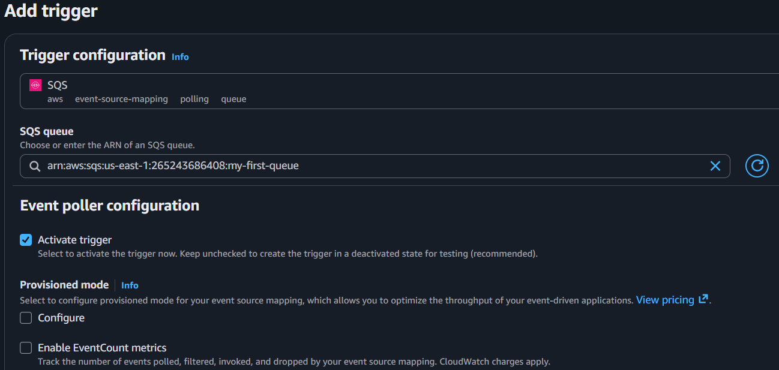
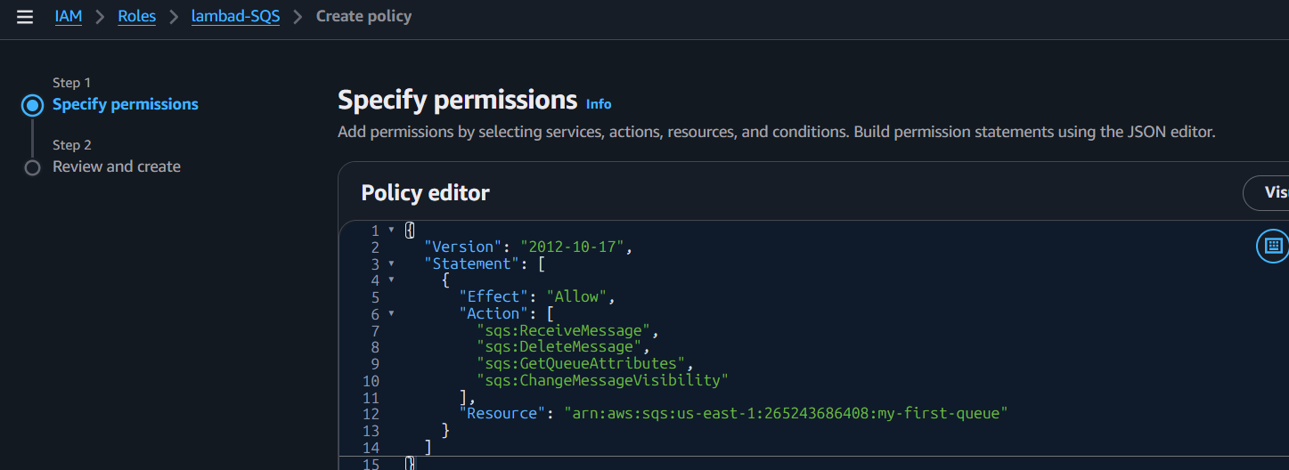

Hands-on 7: Create Queue (AWS CLI)
aws sqs create-queue --queue-name my-cli-queue 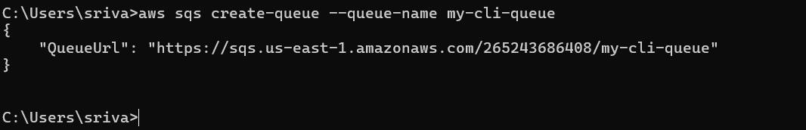

Hands-on 8: List Queues
aws sqs list-queues 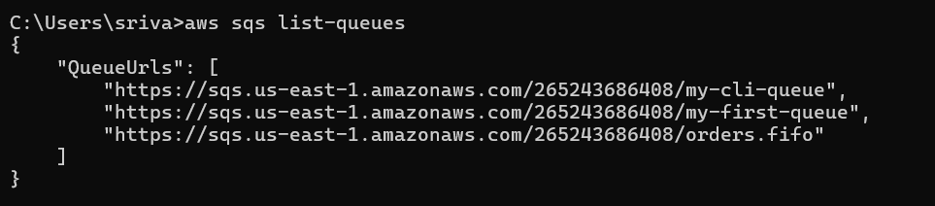

Hands-on 9: Send Message (CLI)
aws sqs send-message --queue-url <QUEUE_URL> --message-body "Hello SQS"

Hands-on 10: Receive Message (CLI)
aws sqs receive-message --queue-url <QUEUE_URL> 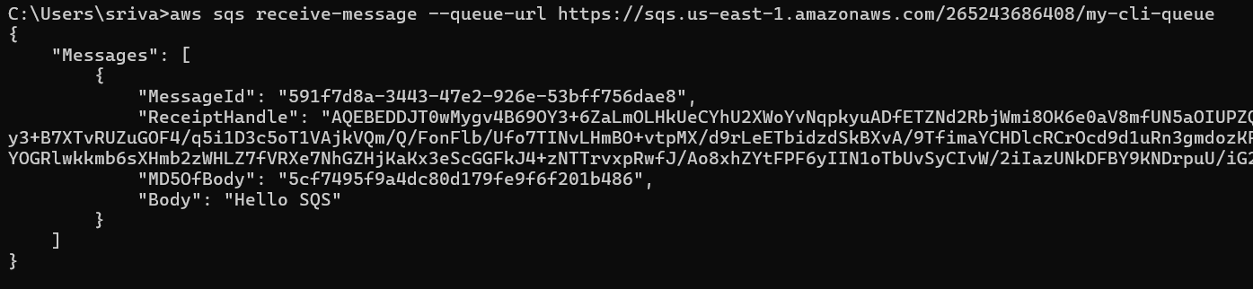

Hands-on 11: Delete Queue
- Open the queue.
- Click Delete.
- Confirm deletion.

Amazon MQ

What is Amazon MQ?
Amazon MQ is a managed message broker service that supports Apache ActiveMQ and RabbitMQ.
Why MQ?
- Migrate existing applications.
- Supports standard messaging protocols.
- Managed by AWS.
Architecture
Application 1
│
▼
Amazon MQ Broker
│
▼
Application 2
Supported Brokers
- ActiveMQ
- RabbitMQ
Common Use Cases
- Enterprise applications
- Banking systems
- Legacy Java applications
- ERP integrations

Amazon MQ Hands-on

Step 1
AWS Console → Amazon MQ
Step 2
Click Create broker
Step 3
Select:
- Broker engine: ActiveMQ
- Deployment: Single-instance
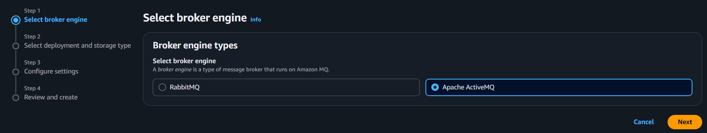

Step 4
Enter:
Broker name: my-broker
Username: admin
Password: Welcome@123
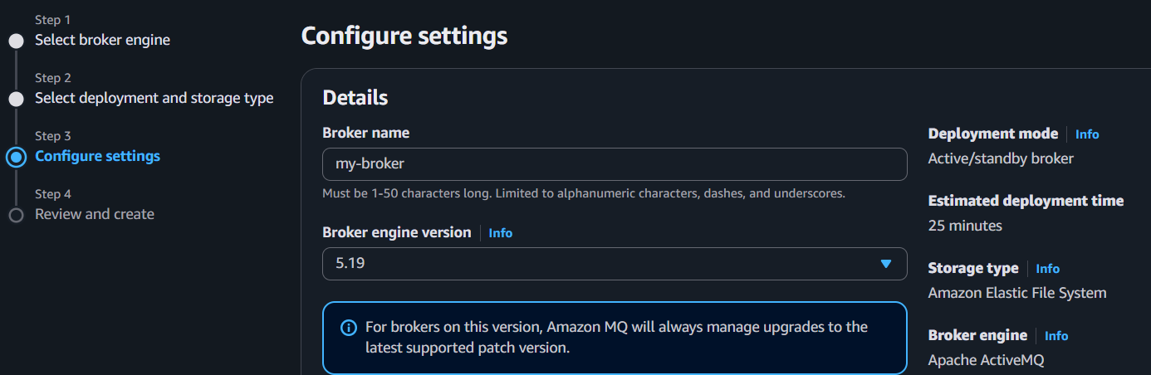
Step 5
Choose:
- Instance type: mq.t3.micro
- Keep the default VPC and subnet.
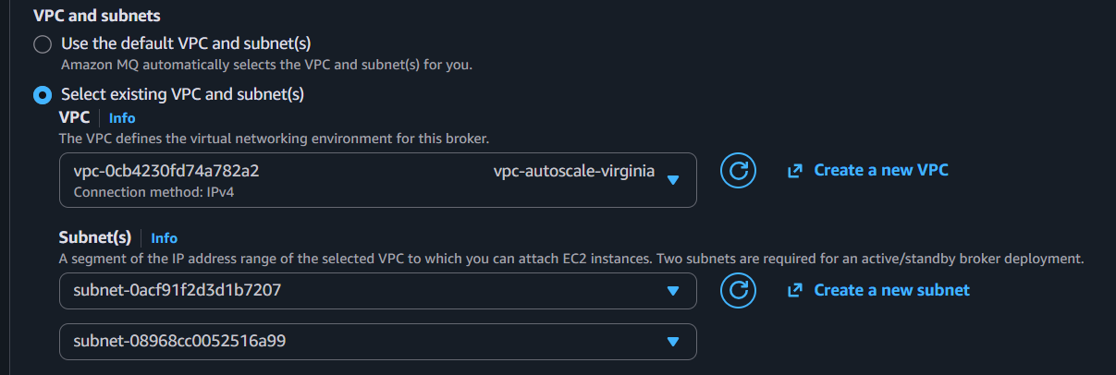
Step 6
Click Create broker.
⏳ Wait until the status becomes Running (about 15–20 minutes).

Verify Broker
- Open my-broker.
- Check:
  - ✅ Status = Running
  - ✅ Broker endpoint is available
